**Microprocessor Systems Design**

**EEE 42101**

**Experiment 1: Environment Setup and LED Blink**

# Objectives:

* Study Basic peripherals and modules of microcontroller.
* Be familiar with the development environment.
* Put hand on the basics of compilation, linking and loading(flashing).

## Tools:

1. PC
2. Arduino Nano board
3. Testing board
4. MiniB-USB cable

Note: all material and sources of this course will be available on:

<https://github.com/ashrafmalraheem/Mircoprocessor_Course>

Feel free to download, study and modify for your own projects.

# Part 1: Compilation

Create or open the template **main.c** files. Study its content. Ensure that it will compile successfully.

You can add any code make some random arithmetic operations.

You can check the output files that you get: **main.asm, mian.o, mian.hex, ..etc**

# Part 2: Setting Registers

In the platform that you are using: Atmega328p in Arudiuno Nano boards. The LED L5 is connected to Port B pin no. 5. You should set this LED to blink at different rate.

First:

you should configure the direction register as output. **DDRB**

Second:

You can then set a value (0 or 1) in the port to switch on the LED.

Use loop to act as a delay.

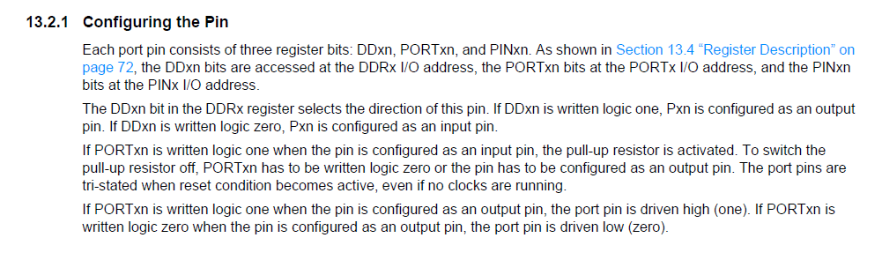

Figure 1 Atmega328p I/O pin configuring

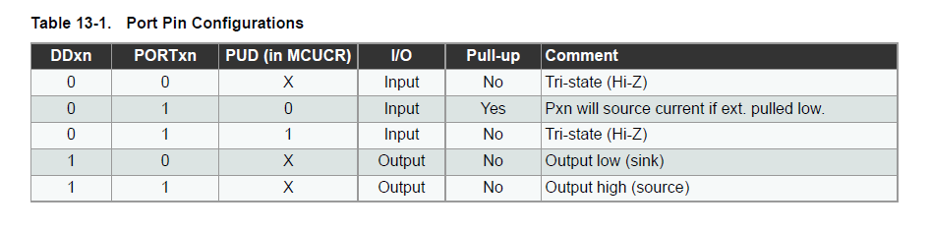

Figure 2 Atmega328p port pin configration

# Part 3: Include libraries

Instead of using the loops as delays now you should include a library to use the delay function.

#include <delay.h>

_delay_ms();

These libraries are precompiled so you can’t find their source code (delay.c). You can only find object codes.

You should search for (delay.h) explore it and find other functions. It is on avr-gcc folder in the MinGW folder in C:/

# Part 4: Make your code smarter

Instead of accessing the registers directly, now you should use functions and macros.

Define a function to set the LED on and OFF depend on the parameter that you pass to them.

1. use macros
2. use functions